BI
Mini Project
Laptop Configuration



Document Control
Table of Contents
Reference No:
Security Classification: | iGATE Internal
Issue Date:
Author(s): | Name |  | Title
Author(s): | Rajita Dhumal |  | Dy Manager
Reviewer(s): | Name |  | Title
Issuer(s): | Name |  | Title
Issuer(s): | Rajita Dhumal |  | Dy Manager
Issuer Signature(s):
Distribution: | Name |  | Title
Distribution: | iLEARN |  | All Designations in iLEARN
Document History: | Date | Revision | Change
Document History: | Dec 2018 | 1.0 | Document creation
1 Introduction 4
1.1 Setup Checklist for Mini Project 4
1.2 Instructions 4
2 Problem Statement 5
2.1 Objective 5
2.2 Abstract of the project 5
2.3 Technology used: 5
3 Implementation in BI LOT 6
3.1 Summary of the functionality to be built: 6
3.2 Guidelines on the functionality to be built: 7
4 Evaluation and assessment parameters 12

Introduction

This document outlines a mini project for the BI LOT. The project is to develop Laptop Configuration.
This document contains the work flow of the system and gives guidelines on how to build the functionality gradually in each of the course modules of the BI LOT.

Setup Checklist for Mini Project
Minimum System Requirements
- Intel Pentium 90 or higher (P166 recommended)
- Microsoft Windows 95, 98, or NT 4.0, 2k, XP, Windows 2007.
- Memory: 32MB of RAM (64MB or more recommended)
- Internet Explorer 6.0 or higher
- Oracle 9i client and access to oracle 9i server
- Informatica 9.5.1
- BOXI R4

Instructions
- The code modules in the mini project should follow all the coding standards.
- Create a directory by your name in drive <drive>. In this directory, create a subdirectory MiniProject. Store your Project here.
- You can refer to your course material.
- You may also look up the help provided in the BI docs and documentation provided with Informatica and Business Objects.

Problem Statement

Objective
Comparative Study of Laptop Specification.

Abstract of the project
Comparative Study of Laptop Specification is a procedure of systematically acquiring and recording information about various laptops and their specifications and comparing product based on their RAM, type, popularity, ratings and price and presenting a optimal idea about better product to opt for.

Technology used:
- Oracle 9i (Database)
- Informatica power center 9.5.1 (ETL Tool):-
- BusinessObjects XI Release 4

Implementation in BI LOT

Summary of the functionality to be built:
The participants need to develop the Laptop Configuration Analysis by building the functionality incrementally in each of the course modules of BI LOT.

Sr. No | Course | Duration | No. of Saturdays | Functionality to be built
Sr. No | Course | (in PDs) | No. of Saturdays | Functionality to be built
1. | Programming Foundation using Pseudo code | 5 | 2
3. | Oracle | 7 | 2
4. | Unix | 4 | 2
5. | Oracle Test | 1 | 2
6. | Informatica 9.5.1 | 6 | 1 | Perform ETL to generate the fact tables and Dimension tables.
6. | Informatica 9.5.1 Test | 1 | 1
7 | BOXI | 5 | 1 | Create a Universe in BO and create Reports
8 | BOXI Test | 1 | 1 | Create a Universe in BO and create Reports
9 | OBIEE 11g | 5 | 1 | Create a package in framework Manager and create reports in Report Studio and Analysis Studio
10 | OBIEE 11g Test | 1 | 1

Guidelines on the functionality to be built:

Project flow

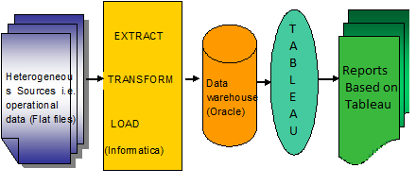

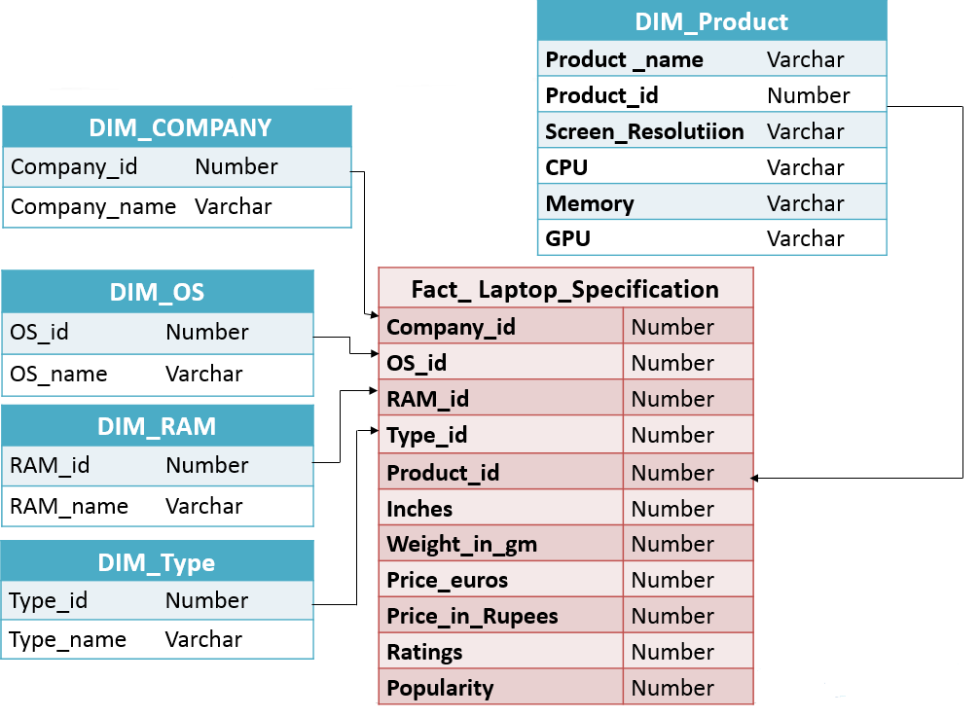
Dimension Model

Schema Design

The project follows the start schema approach.
- The Dimension tables are :
- DIM_Company
- DIM_OS
- DIM_RAM
- DIM_Type
- DIM_Product

- The Fact Table is
- Fact_Laptop_Specification
DIM_Product
Product _name | Varchar
Product_id | Number
Screen_Resolutiion | Varchar
CPU | Varchar
Memory | Varchar
GPU | Varchar

DIM_COMPANY
Company_id | Number
Company_name | Varchar

DIM_OS
OS_id | Number
OS_name | Varchar

Fact_ Laptop_Specification
Company_id | Number
OS_id | Number
RAM_id | Number
Type_id | Number
Product_id | Number
Inches | Number
Weight_in_gm | Varchar
Price_euros | Number
Price_in_Rupees | Number
Ratings | Number
Popularity | Number

DIM_RAM
RAM_id | Number
RAM_name | Varchar

DIM_Type
Type_id | Number
Type_name | Varchar

Note: The datatype/length for the Dimension/Fact table attribues can be changed as required. Additional fields can be added, if required.

The Dimensions are Dim_Company, Dim _ OS, Dim _ RAM, Dim _ Type, Dim _ Product.
- COMPANY:
This dimension contains information about the name of the Company
- Company_Id
- Company_Name
- OS:
This dimension contains Operating System of each laptops
- OS_Id
- OS_ Name
- RAM:
This dimension contains RAM processor of each laptops
- RAM_Id
- RAM_ Name
- TYPE:
This dimension contains Type name of each laptops
- Type _Id
- Type _ Name
- PRODUCT:
This dimension contains Product details of each laptops like screen resolution,CPU,memory,GPU
- Product _ Name
- Product_id
- Screen_Resolution
- CPU
- Memory
- GPU
The Fact is Fact_ Laptop_Specification.
- Fact_ Laptop_Specification:
This is a Fact table that contains the specification and memory related information of laptop and the company which it belongs to.
- Fact_id
- Company_id
- OS_id
- RAM_id
- Type_id
- Inches
- Weight_in_gm
- Price_euros
- Price_Rupees
- Ratings
- Popularity

Sample Reports

